Christie Templeton
Sample Software Training Manual

The following is an excerpt from a software training manual created previously for the purpose of training employees in the field on a new software being launched.
Table of Contents
Table of Contents 3

Chapter 1
Getting Started 1
Overview - Getting Started 1
Signing into the System 2
Summary - Getting Started 10

Chapter 2
Sales & Returns 1
Sales 1
Overview - Sales 1
Learning Level I 2
Learning Level II 175
Returns 222
Overview - Returns 222
Learning Level I 222
Learning Level II 233

Chapter 3
Dispatch 1
Dispatch - Main 1
Dispatch Part 1 - Truck Route / Manifest 2
Dispatch Part 2 - Changing (Flipping) a Work Order Part 10

Chapter 4
Accounting 1
Overview - Accounting 1
Accounts Receivable 2
Account Payments - A2,3 2
Aging Report - X3,4 16
Back Office Transaction Report - A2,6 18
Customer Data - A1,1 19
Daily Cash Report (DCR) 23
Sales Journal - X1,1 34
Statements - A2,5 35
Accounts Payable 37
Vendor Invoice Payments (Purchase Orders) 37
Tips and Tricks 40
Summary - Accounting 41

Chapter 5
Inventory 1
Overview - Entering New Vehicles 1
Entering New Vehicles 2
Checkin 5
Creating a Dismantling Report 10
Add Parts to Existing Vehicle 11
Printing Tags 13
Title Work 14
Bulk Move 14
Bulk Purchase 19
Add Parts into Bulk Purchase 21
Pickup Queue 26
Restocking 27
Summary - Entering New Vehicles 28

Chapter 6
Reporting 1
Reporting - Main 1
Inventory Reporting 2
Overview - Inventory Reporting 2
Advanced Inventory Batch Parameters - Z6,9 3
Inventory Projection - Z6,6 10
New Profitability Report - I3,14 13
Parts - I2,1 14
RACK Audit Report - I3, 13 15
The M Menu 17
Summary - Inventory Reporting 18
Management Reporting 19
Overview - Management Reporting 19
New Daily Journal X4,3 20
Intercompany Sales Report - X5,2 22
Inventory Status Report - I3,7 24
Profitability Report - I3,4 or X2,7 25
Quote Detail Report - X4,1 26
Sales Journal Report - X1,1 28
Sales Master Report - T1,1 30
Weekly Productivity Report (WPR) 34
Summary - Management Reporting 42
Sales Reporting 43
Overview - Sales Reporting 43
Open Work Orders - X1,3 44
Purchase Order Report - X1,2 46
Reporting - T1,1 47
Summary - Sales Reporting 52

Appendix A
Reference 1
Menu Choices 1
Contacts 3
Change Log 4
Document Information 6
Training Objectives 7

Appendix B
Glossary 1

Appendix C
Index 7

Getting Started

Overview - Getting Started
Notes:
- Check off each line where you understand the information or process. Any lines unchecked should be presented to your trainer for further clarification before moving onto the next page or section.

In this section you will learn:

- The Address / URL for the software to enter into the Internet Explorer address bar.

- How to use the Expert Direct function.

- How to navigate to the Menu & Screens.

- How to create multiple sessions.

- How to close out of a session.

- How to find the Help screen.

Signing into the System
Notes:
- If after signing into the software your window closes, check if you have a pop up blocker running. Make sure pop-up blocking software is disabled as they will cause this problem.

Login
The software is a remotely ran application, it resides on a server and not on your desktop. You must be logged into the LKQ network. You will access the software through a web browser.

- Open up Internet Explorer.
- For access to the test environment type lkqpxweb3/security into the address bar as shown (Screenshot). Make sure that the border is green in the window which signifies this is the test box. The production has a blue box.

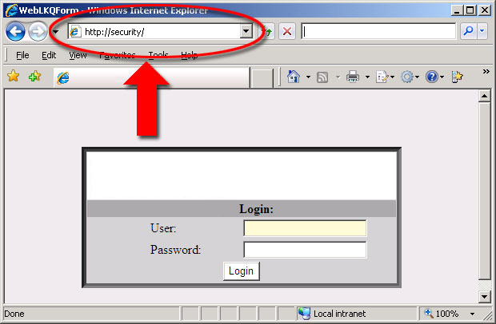

 | - Clicking the link above will launch the software for you.  - You will be given a link to the production environment by your manager.

- At the software sign in screen enter your: (Screenshot)
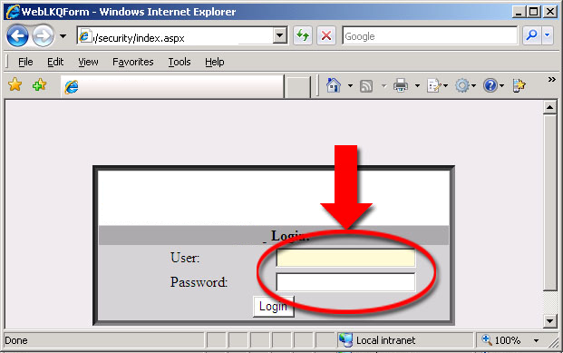

- User Name (Network Login)
- Password (Network Password)
- You will arrive at the main the software screen (Screenshot)

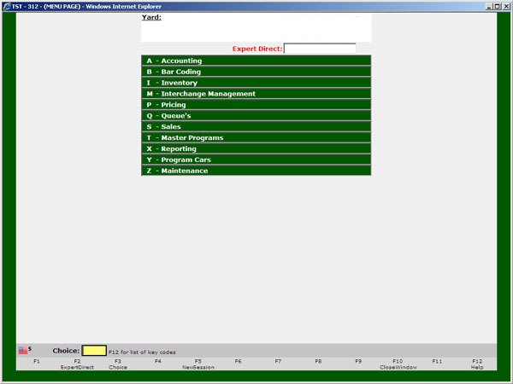

Note: Your screen may not have the same menu choices as shown. Your menu will depend on what your manager sets up for you.
- You will be automatically logged into your "Home" yard when you sign into the system. (Screenshot)

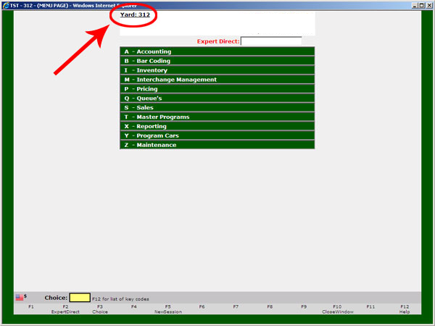

If you have login problems contact the help desk at 1-877-555-6336.

Expert Direct
The Expert Direct field allows you to jump directly to a menu choice. For example you can enter S1,1 and press the enter key to open the Customer Search screen. You can also enter codes to access specific invoices, work orders, quote, purchase orders, yard or you can scan inventory for specific stock numbers. Use the following table to aid you with entering codes in the Expert Direct field:

Code | Action
I## (I with Inv Number) | Jumps to a specific invoice
W## (W with WO Number) | Jumps to a specific work order
Q## (Q with QUOTE Number) | Jumps to a specific quote
P## (P with PO Number) | Jumps to a specific purchase order
Y### (Y with Yard Number) | Jumps to another yard
S### (S with stock number) | Scans the inventory for stock number

You can enter your code in this field by clicking in the box with your mouse, or you can press F2 to jump directly to the Expert Direct Field. (Screenshot)

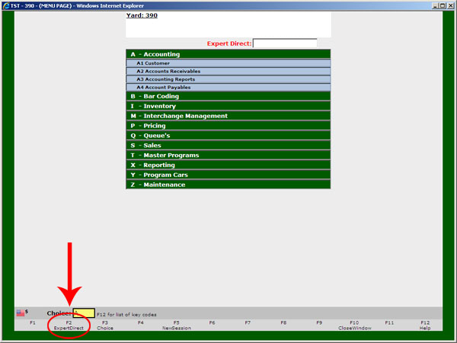

Screen/Menu Navigation
The menu in the software is broken out into Main menu headings followed by Sub-menu Headings followed by Screen names. You can navigate to the screens you need more than one way. For most all screens there are 3 methods, not including the Part Request screen which has a 4th option.

Method 1
Clicking Through the Menu - You can click through the menu at the top as shown in this screenshot.
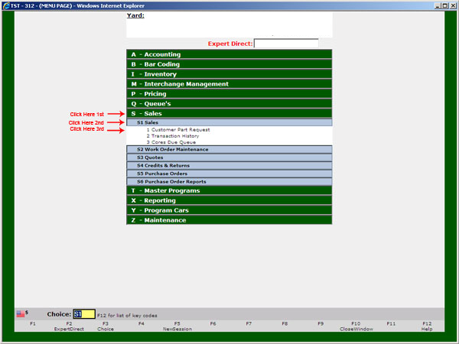

Method 2
Using the Choice Field - Enter the Sub-menu code followed by a comma then the screen name. For example to navigate to the Customer Part Request screen you would enter "S1,1" and press enter.

Method 3
Using the Expert Direct Field - Enter the Sub-menu code followed by a comma then the screen name. For example to navigate to the Customer Part Request screen you would enter "S1,1" and press enter.

Method 4
Using Key Commands - Press the Ctrl key and the X key simultaneously to get to the Customer Part Request screen (S1,1). This is the only key combination available in LKQX.

Note: You can enter your code in this field by clicking in the box with your mouse, or you can press F3 to jump directly to the Choice Field. (Screenshot)

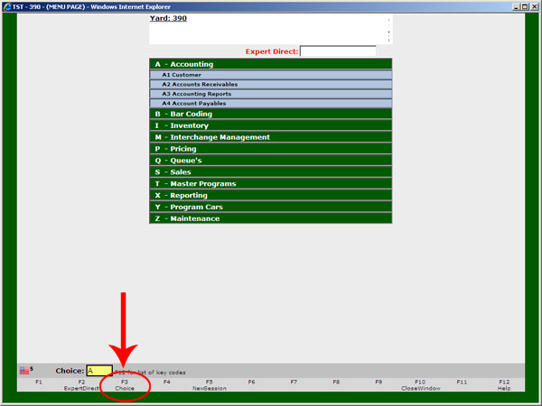

Multiple Sessions / Windows
You can create multiple sessions without having to log in again by pressing the F5 key on your keyboard or by clicking the icon. You can only have a maximum of 3 sessions open at any given time.

Closing the Menu
You can close (sign out of) the window by pressing the F10 key on your keyboard or by clicking the X at the top right corner of the screen. (Screenshot)

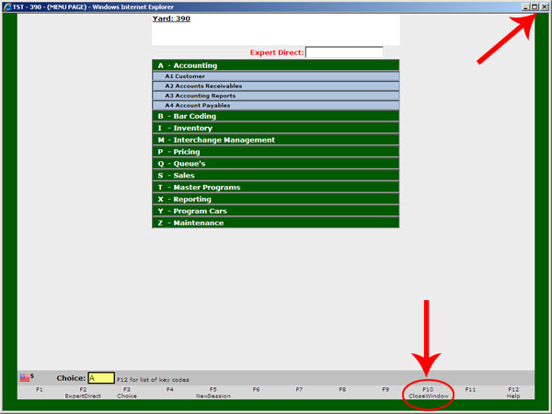

Help
You can Press the F12 key on your keyboard or click the icon with your mouse to view the Help screen.

Note: The help menu will list all of the options that you have from this screen within the choice field. (Screenshot)

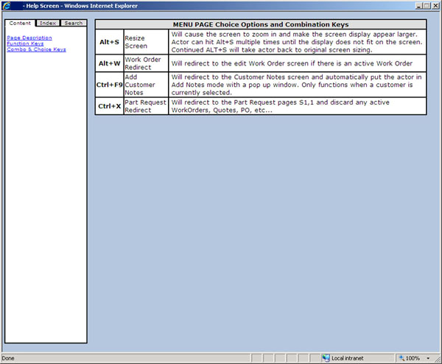

Summary - Getting Started

You should now understand how to:
Open Internet Explorer.

Enter the correct address / URL to launch the the software application.

Login to the software with your Username & Password.

Use the Expert Direct field.

Use the Choice field.

Navigate through the Menu & Screens.

Create multiple session, and know the maximum amount you can create at any one time.

Close out of a session.

Access the Help screen.

End Sample Software Training Manual

